Panama
Canal Zone & Chiriqui Highlands
February 18 - 27, 2011
TRIP REPORT

Disclaimer: This report is as accurate as possible using limited notes taken in the field; any errors regarding species seen at specific sites are unintentional. For the most part, species are listed only on the day they were first seen unless the subsequent sighting involves something significant.

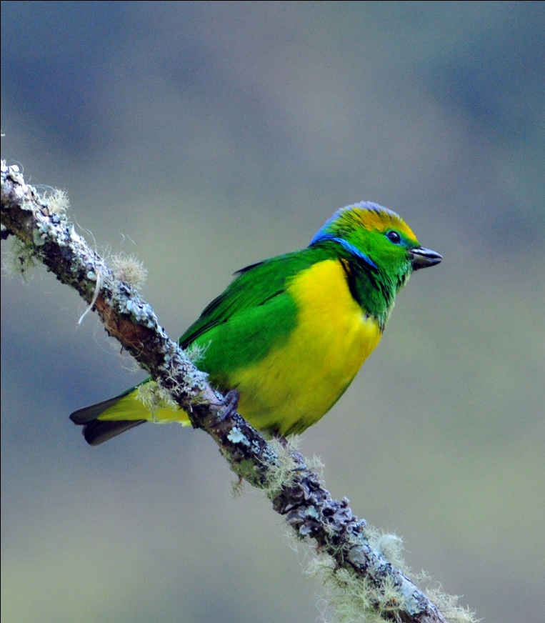
Species seen by group: 350
Additional species heard: 23
Birding guides: Guido Berguido, Michael Castro
Tour leaders: Cindy and Jim Beckman (owners,
Cheepers! Birding on a Budget)
Group: 8 + 2 tour leaders and guides
4 birders from UT, 2 from WA, 2 from TX
Highlights: Six male and 3 female Resplendent Quetzals in one fruiting tree, Golden-browed Chlorophonia male and female building a nest, Scaly-throated Leaftosser, Ornate Hawk-Eagle, Rufous Nightjar, Long-tailed and Black-and-Yellow Silky- Flycatchers, Yellow-bellied Tyrannulet, Barred Becard, Silvery-fronted Tapaculo, 27 species of Hummingbirds including Veraguan Mango, 46 species of Tyrannidae (Tyrant Flycatchers), 13 species of Typical Antbirds (Antshrikes, Antvireos, Antwrens, Antbirds)

Day 1, Friday, Feb. 18: Jim and I woke up to a 3:15 alarm for our 7:10 flight out of Cincinnati. We arrived in Panama City at 1:30 and made it through customs in less than 15 minutes, a record for us at any international airport. We phoned Guido right away because we figured he wouldn't be there for another hour or so since our plane landed a little early and it took such a short time in the airport. He was nearby, on his way to pick up the Bonds, who had arrived a day early and had gone on a partial canal transit today. He swung by the airport and grabbed us and then we went to fetch the Bonds.

Upon arrival at the Soberania Field Station and Lodge, we joined the Bonds in the dining room to observe some common feeder birds. Palm Tanager, Blue-Gray Tanager, Clay-colored Thrush, Red-legged Honeycreeper, Green Honeycreeper, and Red-crowned Woodpecker all stopped in to feast on the bananas and watermelon provided for them, just as they would on every day of our stay there. I heard a Chestnut-mandibled Toucan calling, and we moved to the front of the building to see if we could locate it. After a short while, the bird came into view not far from our position. Back in our seats viewing the feeders, we enjoyed visits from Crimson-backed Tanagers, a Rufous-tailed Hummingbird, and a lone Whooping Motmot, a species which was recently split from the Blue-crowned Motmot. The current status of the species is a bit vague, so we left without being certain if this split has been accomplished or if it is pending.

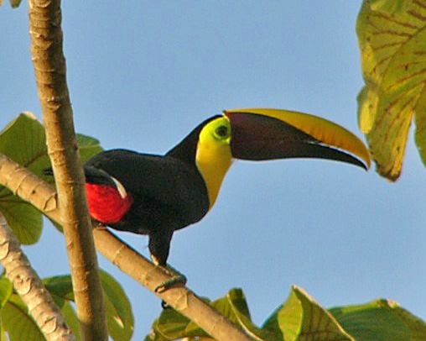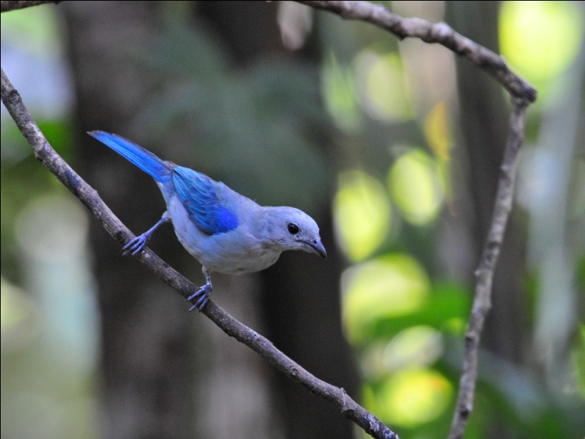
Chestnut-mandibled Toucan Blue-gray Tanager

As we were watching the feeders and getting to know each other, Guido heard some Purple-throated Fruit Crows, so again we hurried to the front of the building to locate them. Shortly after, Guido left to begin a series of airport runs to gather the rest of our group. One couple was scheduled to arrive at 7:32, two couples would arrive at 9:48, and the last two people would come in at 10:35. It would be around midnight before all members of our party made it to their rooms.

The Bonds and Jim and I walked to the nearby Gamboa Rainforest Resort to have dinner, chatting along the way. In spite of our preoccupation in getting acquainted, we managed to see some new trip birds as we walked (Great Kiskadee, Little Blue Heron), and enjoyed watching a gorgeous full moon rise over the Chagres River. After walking back to the lodge, we went to our rooms to rest for the big day that was planned for tomorrow. I had intended to go downstairs to meet and greet each participant as they arrived, but I quickly fell sound asleep and didn't hear much of anything until around 4:30 AM. (That can happen when you get up at 3:15 AM)

Day 2, Saturday, Feb. 19: When I heard people at 4:30 AM, I thought that the kitchen staff was coming in extra early to prepare breakfast and realized that I hadn't asked Guido what time we should be ready to start in the morning. I tried to go back to sleep, but finally got up around 4:45 and got ready to go. When I stepped outside our room shortly before 6:00 AM, I could see that it was pitch black outside! I could see that the Bonds were also up and ready to go, so the three of us just had to wait for daylight to come. We learned at breakfast (at 7:30!) that the last two people didn't arrive until 4:30 AM. Their flights had been delayed, and the sounds we heard in the wee hours of the morning were two very tired ladies from Texas. We didn't expect them to join us until after lunch on this first day.
Before breakfast, the Bonds and I did some birding in front of the lodge. A large tree across the street had few leaves on it and afforded us wonderful views of anything that landed there. And land there they did - Keel-billed Toucans, Orange-chinned Parakeets, and several flycatchers we could not identify were among the first to arrive. Some Red-lored Parrots landed, and we watched as a pair mated before they flew off. By now, some others had come down from their rooms, and we introduced ourselves to each other as we continued to enjoy the show. Chestnut-mandibled Toucans flew into view, although they did not land in "our" tree. A female Black-throated Mango flew into a lower bush near where we were standing. We all recognized the rattle of a kingfisher and looked skyward as a huge Ringed Kingfisher flew over the house.

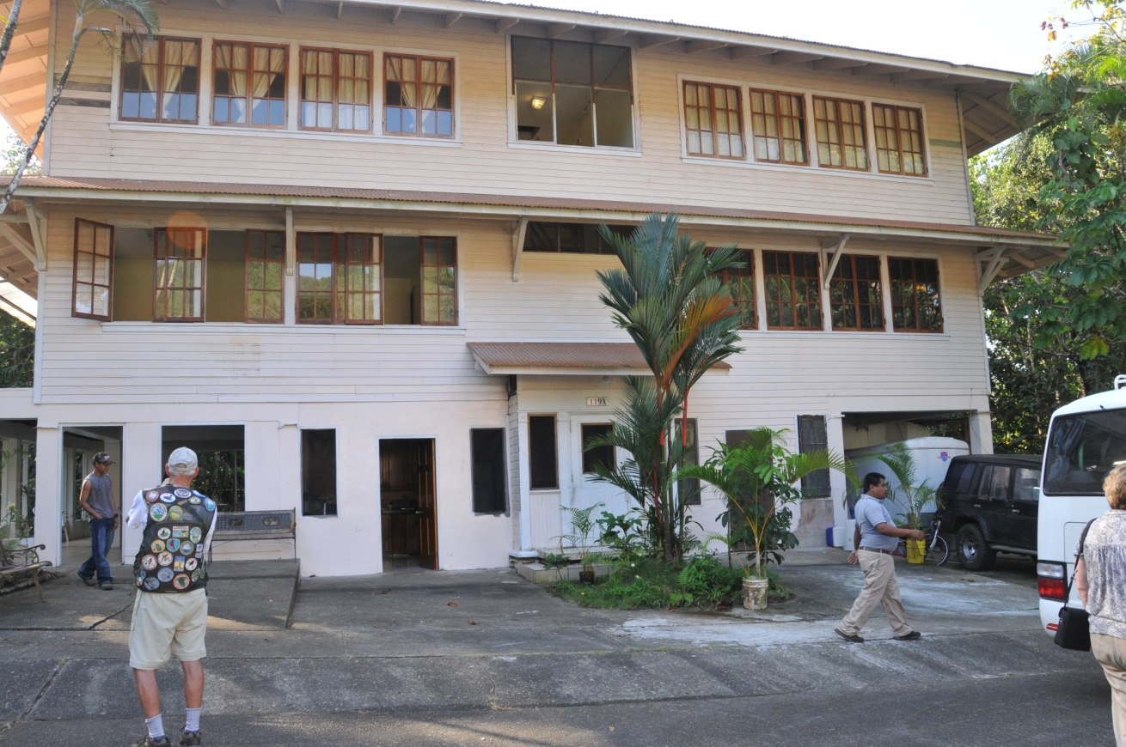
Soberania Field Station and Lodge

After breakfast, we enjoyed the feeders some more, waiting for our van to arrive so we could go off on our first adventure. To our surprise, our Texas friends came down at around 8:15. Jesus, the wonderful cook who provided our meals at Soberania Lodge, quickly served them some breakfast. As they ate, Orange-chinned Parakeets returned to the same tree, and Gloria and Roseann rushed outside to see them. Eating meals is no easy task here with this much bird activity at your doorstep!
Shortly after they finished eating, the van showed up and we were off to the Ammo Dump, just a few minute's drive from the lodge. Before we could get there, we had to stop by some dead trees near the lodge to observe a pair of Black-crowned Tityras that appeared to be gathering nesting material. Normally a roosting spot for a pair of Bat Falcons, these trees often have something of interest around them. While watching the Tityras, we noticed a Southern Rough-winged Swallow on one of the branches.

The Ammo Dump is an area where, well, ammo was dumped. This area was used to store ammunition during World War II near the pipeline that was built across the isthmus as a precaution in the event the Japanese destroyed the canal. Of course, this never happened, the pipeline was never used, and the area known as the Ammo Dump is now (still?) fenced off. Whether it's restricted because of the risk of remaining ammunition in the area, I don't know. There are some ponds nearby, and the combination of the ponds and the marshy area around the Ammo Dump provides some excellent birding opportunities.

Every time we approach the fence at the Ammo Dump, I remember the first time I birded there and how thrilled Guido and his friend and fellow guide, Beny, were that the White-throated Crake came out in the open for us. This is still the best place to see White-throated Crake, one of those secretive birds that is more often seen than heard.

On the roadside in front of the fence, we quickly racked up an impressive list of birds: Yellow-rumped Cacique, Wattled Jacana, Barred Antshrike, Scrub Greenlet, Variable Seedeater, Piratic Flycatcher, Great Kiskadee, House Wren, and a female Oriole that remained unidentified. Just as we prepared to leave, one birder was giving instructions to another for a last look at one of the species we had seen. When Pam looked in the direction given, she saw a group of White-faced Capuchins in the trees! A great start for our very first stop.

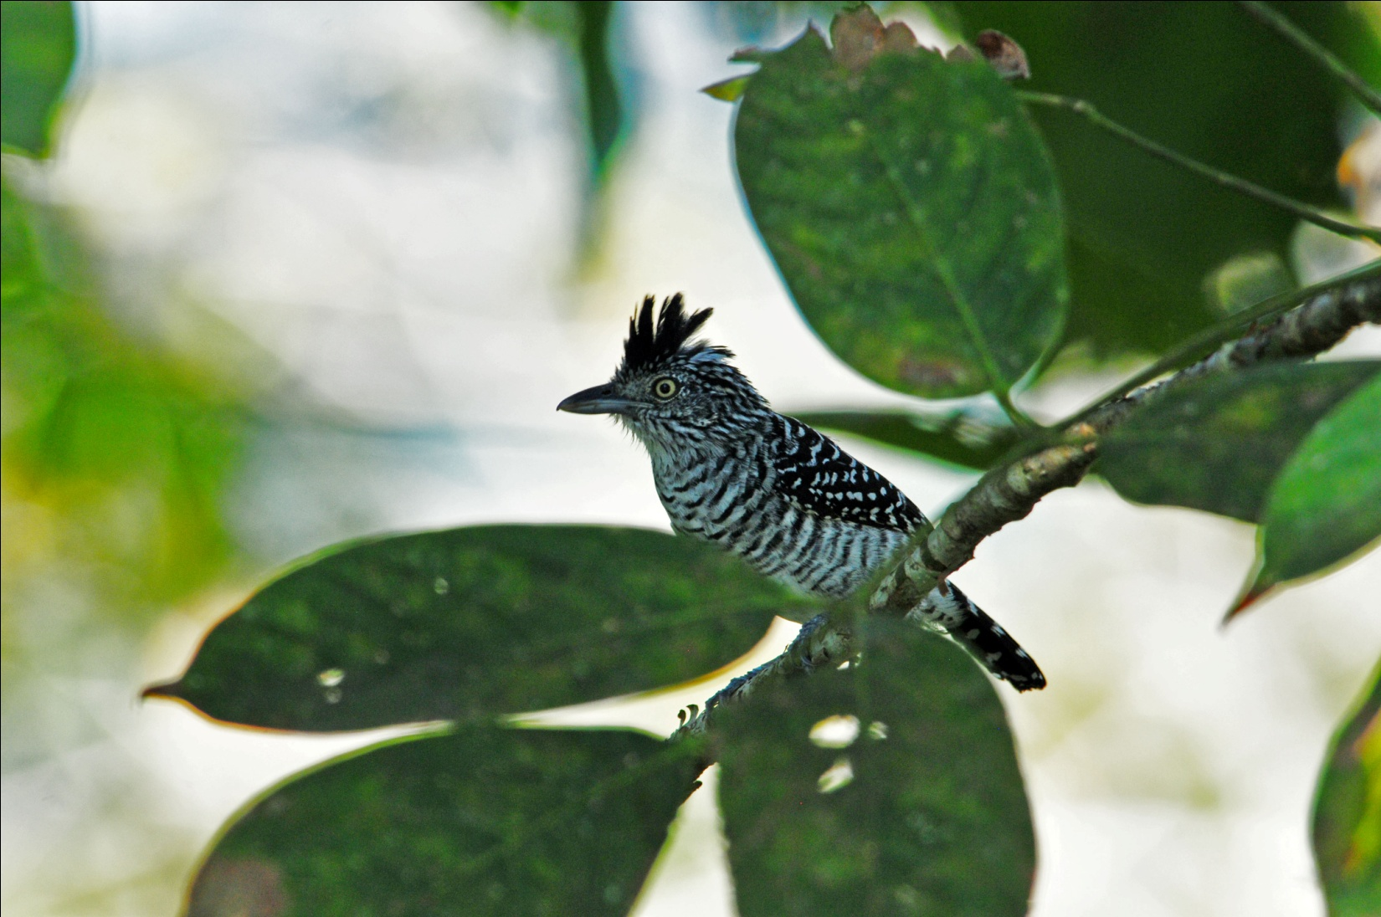
Barred Antshrike

We went on to the ponds, where the first bird we saw was a Rufescent Tiger-Heron . This bird sat quietly at the edge of the marsh closest to the road, never flinching as one person after another approached closely for photographs. I've seen a lot of Tiger-herons, but never one this close or this cooperative! Also on the ponds were Great Blue Heron, Wattled Jacana, Purple Gallinule, and the always-heard, rarely-seen White-throated Crake. Some of our group actually got to see the crake; others just heard it.

Before going back to the lodge for lunch, we stopped at the entrance to Pipeline Road, one of the most famous birding sites in Panama. The day was warming up by now and there was not a lot of bird activity in the area. A Golden-collared Manakin teased us and we spent a bit of time trying to see the very vocal bird, but we eventually concluded that we were wasting our time on this little guy. Probably accustomed to hearing taped calls on a daily basis, this bird was not going to respond to our calls. Guido was optimistic about our chances to see another individual of this species as we continued our tour, but we never did get to see one.

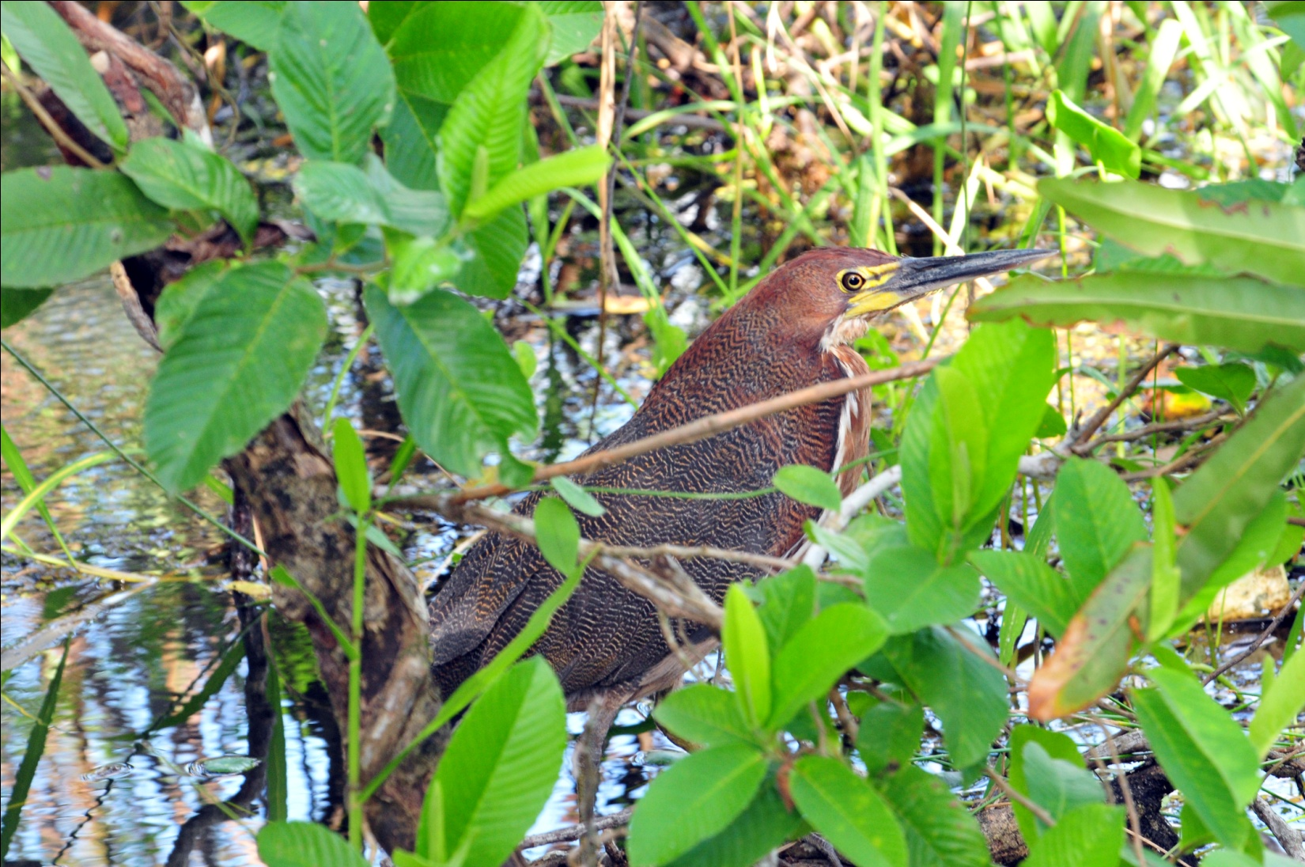
Rufescent Tiger-Heron

Our next stop was the marina of the Gamboa Rainforest Resort. As we drove in, we spotted several Southern Lapwings in a grassy area near the road. From our vantage point near the parking lot, we found Common Moorhen, Social Flycatcher, Lesser Kiskadee, Mangrove Swallow, Yellow-bellied Elaenia, and Piratic Flycatcher. On the far side of the inlet, a Cinnamon Woodpecker landed and remained perched long enough for everyone to get excellent scope views. A short walk yielded Bay-breasted Warbler, Red-throated Ant-Tanager, Forest Elaenia, Gray-headed Chachalaca, Keel-billed Toucan, and Plain Brown Woodcreeper. A young male White-necked Jacobin in poor plumage and poor lighting would have been impossible to identify without Guido's expertise.

We drove back to the lodge and arrived at around 11:45. Watching the feeders is always a delight, especially for new arrivals who haven't seen the common feeder birds yet. As we waited for lunch to be served, all the regulars showed up, including at least four male and two female Red-legged Honeycreepers who jockeyed for positions at the hummingbird feeders as well as feasting on the platform feeders stocked with fruit. A Buff-throated Saltator landed among the smaller tanagers and honeycreepers, making quite an impression on our group of birders.

We took a break after lunch, much appreciated by the ladies who had less than four hours of sleep the night before. Most of the others birded around the lodge, and some took a walk around the neighborhood in search of new species. Cocoa Woodcreeper appeared in the yard, although not at the feeders. Other new species seen by these birders during the lunch break included Blue Dacnis and Plain-colored and Flame-rumped Tanagers. At 3:00 PM, we piled back into the van to head for Plantation Road.

Plantation Road is one of those feast-or-famine kind of places. My experience is that, especially in the afternoon, it can leave a lot to be desired. Today, however, we were not disappointed. As soon as we exited the van, we had male and female Fulvous-vented Euphonias overhead. In addition to seeing multiple individuals of the more common species, we got great looks at several species new to the trip; Broad-billed Motmot, Rufous Motmot, Western Slaty and Fasciated Antshrikes, White-tailed Trogon, Slaty-tailed Trogon, Plain-brown and Cocoa Woodcreepers, Purple-throated Fruitcrow, Red-capped Manakin (female), Buff-breasted Wren, Scarlet-rumped Cacique, and White-whiskered Puffbird all provided us with great views. Overhead, we saw a kettle of Plumbeous Kites soaring, with excellent lighting for observing the rusty patches in their wings. Howler Monkeys made their first appearance for the week, with adult males and mothers with babies clinging to them in the troop.

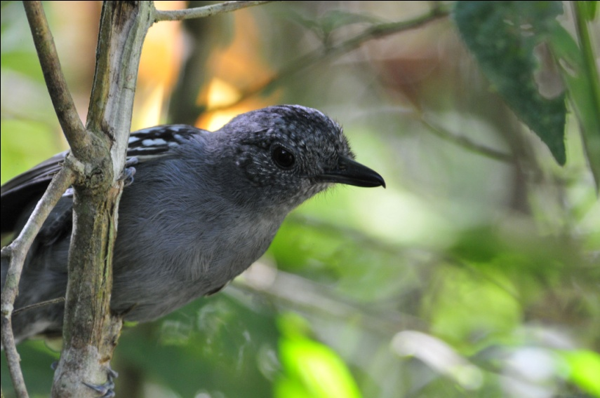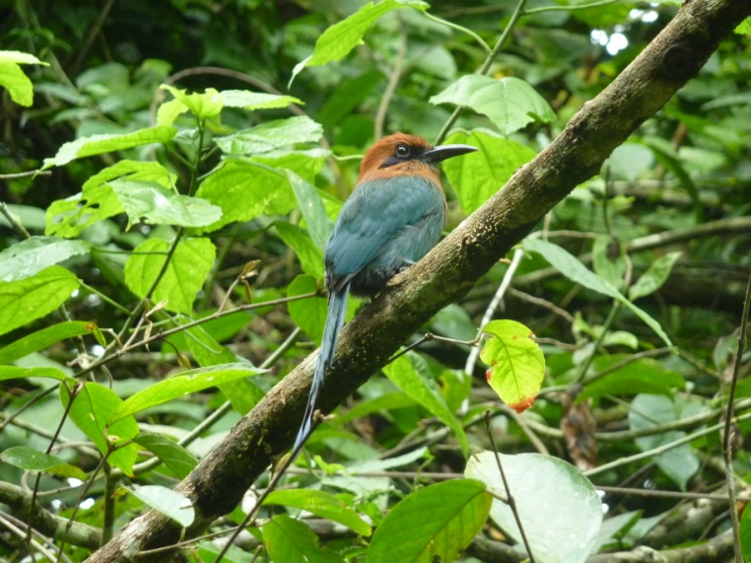
Western Slaty Antshrike Broad-billed Motmot

Driving back to Gamboa, we spotted a Fork-tailed Flycatcher as the van sat waiting to cross the bridge. This is the same area where we saw a Tropical Mockingbird the day before, and where we nearly always see Gray-breasted Martin. Magnificent Frigatebirds were flying over the canal. Back at the lodge, Guido pointed out the calls of Yellow-headed Caracara and Great Tinamou as we ate dinner.

Other birds seen today included Black and Turkey Vultures,Great-tailed Grackle, Pale-vented Pigeon, Ruddy Ground-Dove, White-tipped Dove, Short-tailed Swift, Great-crested Flycatcher, and Tropical Kingbird. We finished our day with 75 species seen by the group with another 20 heard only and 2 seen by Guido only. Quite a successful first day, especially considering the late start we got, but the idea of having 20 "heard only" species in a single day was a bit disconcerting - did we really miss that many birds, or was Guido so good at hearing the calls that the birds were not within observable distance?

Day 3, Sunday, Feb. 20: Today the group opted for an early breakfast so we could depart at 6:30 to bird the famous Pipeline Road. With perfect weather and a gentle breeze, this was the most pleasant day I've ever spent on Pipeline - I barely borke a sweat! As soon as we got out of the van, Guido heard a Laughing Falcon calling. We walked a short way down the road that leads to the Rainforest Discovery Center to find the falcon before beginning our walk down Pipeline Road. Most of the group got to see the bird through the scope before it flew away. Before we made it back to the main road, a pair of Crimson-crested Woopeckers caught our attention. As we started down Pipeline Road, Guido heard the sounds of Blue-black Grosbeaks ahead of us. We approached slowly and caught a glimpse of the male and female, but were distracted by a couple of Gray-headed Tanagers. We spent a few moments getting everyone on the Tanagers, and as we walked away the Grosbeaks returned and gave everyone nice clear looks at them.

We did not encounter the ant swarm that we were hoping for, but we saw a nice variety of birds as we proceeded down Pipeline Road: Slaty-tailed Trogon, Violet-bellied Hummingbird, Brown-capped Tyrranulet.
Then, the tiniest bird in the forest made the biggest impression on our group. A Black-capped Pygmy-Tyrant flitted about overhead, and we observed it until everyone had a chance to see field marks (other than its belly). Two Slate-colored Grosbeaks were heard, but no one was able to locate them at first. Finally one of them flew into view and was quickly joined by its mate. A Dusky Antbird moved about at eye level as White-shouldered Tanagers foraged higher in the trees. At one point, the group was ambling along with a lot of space between people. The people in the front of the line were rewarded with fleeting views of a Great Tinamou as it crossed the path in front of them. At another spot on the trail, Jim pointed out a bird in the back layer of forest and asked if I knew what it was. At first, I saw more White-shouldered Tanagers in the area he was pointing out, but then a Black-chested Jay emerged from its leafy hide-out, paused for a second and then shot down into the thick brush below, where we could not see. Guido questioned my identification, but I was positive of what I had seen. He said it was unusual for the Jay to be alone and to be quiet, and he thought we should not count the bird for the day.

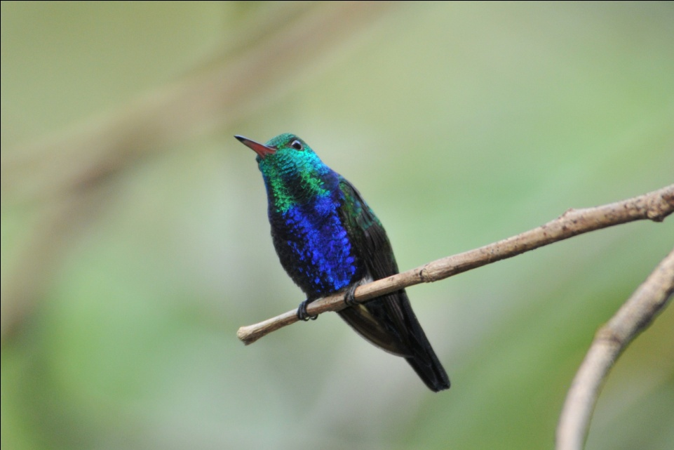
Violet-bellied Hummingbird
As we continued, the parade of birds was pretty consistent: Red-throated Ant-Tanager, White-flanked, Dot-winged and Checker-throated Antwrens, White-tailed Trogon, Violaceous Trogon, Yellow-margined Flycatcher, Black-breasted Puffbird, Great Jacamar, Plain Xenops, Tropical Gnatcatcher, Black-striped Woodcreeper. We spent a bit of time locating and then helping everyone get good looks at a Chestnut-backed Antbird. All the while we were walking, we heard the almost continuous sound of the Green Shrike-Vireo calling "Peter Peter Peter" like a Tufted Titmouse with a southern accent. Finally, much to everyone's surprise, we actually got good looks at this bird whose call is usually heard from the treetops where its unlikely to be visible. Much deliberation was given to the identification of a Blackpoll Warbler, looking very much like a Bay-breasted Warbler in its winter plumage. Also seen was a Chestnut-sided Warbler.

As we were standing quitely listening to the sounds of the birds around us, I noticed a large shape in the distance and alerted Guido to the presence of a hawk. He immediately identified it as a Semiplumbeous Hawk. The hawk sat patiently as everyone got a good look through the scope, and it remained stationary as we continued down the trail and walked right beneath its perch.

As we were approaching the end of our walk, we met another group of birders who pointed out a Tamandua, a type of arboreal anteater that is normally active at night. Walking about on the ground in broad daylight, it was obvious that this guy hadn't read the book on anteaters. This was my first sighting of an anteater of any kind in the wild, and I was very excited to be able to observe and photograph it.
http://www.ceiba.org/articles/tamandua.htm

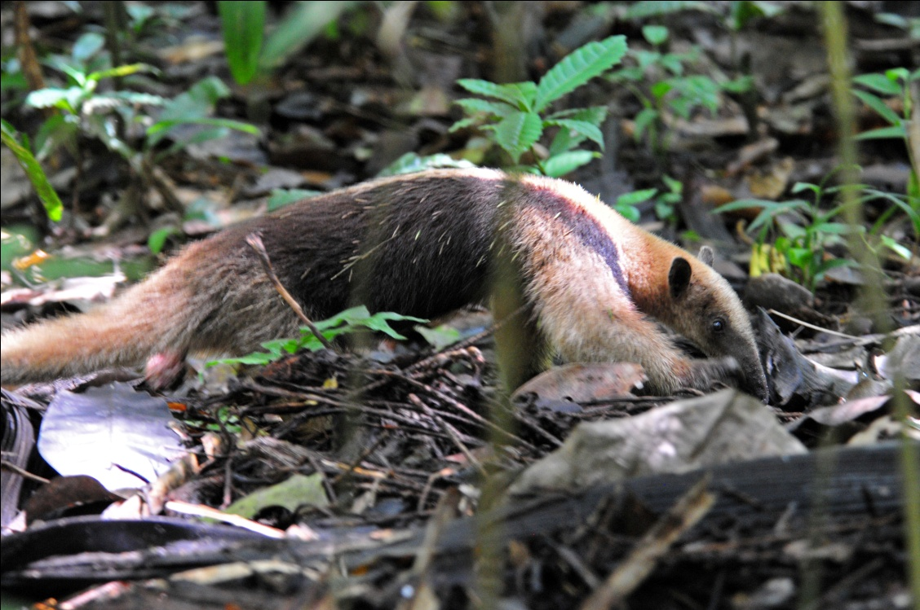
Tamandua

As we left Plantation Road, we spotted a Yellow-headed Caracara from the van. People in the back of the van did not see it, but Guido assured us that we would have many opportunities before the end of the tour.

Staying in a lodge so close to the hot birding spots is quite an advantage when it's time for lunch. We returned for more of Jesus's delicious food at noon and, as we were finishing lunch a Golden-hooded Tanager joined the regular feeder crowd in the yard.

After a brief break, we moved on to the Rainforest Discovery Center, located in the vicinity of Pipeline Road. Only in existence for a few years, the Center features well-maintained trails, a visitors' center with feeders, a nice lake, and a 40-meter tall observation tower. We started at the Visitors' Center to view the hummingbird feeders. Arriving at 2:30 PM, the lighting and the activity wasn't at its best, but we enjoyed seeing Long-billed Hermit, White-necked Jacobin, Violet-bellied Hummingbird, Rufuous-tailed Hummingbird, Blue-chested Hummingbird, and White-vented Plumeleteer in just a short time.

We next walked a short trail that led to a lake. Along the way we observed Violet-crowned Woodnymph, Broad-billed and Whooping Motmots, Black-striped Woodcreeper, Ruddy-tailed Flycatcher, Southern Bentbill, Long-billed Gnatwren, and Black-tailed Trogon. Guido pointed out the diagnostic field mark that let us know the female trogon we were seeing was a Black-tailed rather than a Slaty-tailed female - bill color was dramatically different. I'm not sure if bill size is also different, but that bright golden bill certainly looked huge!

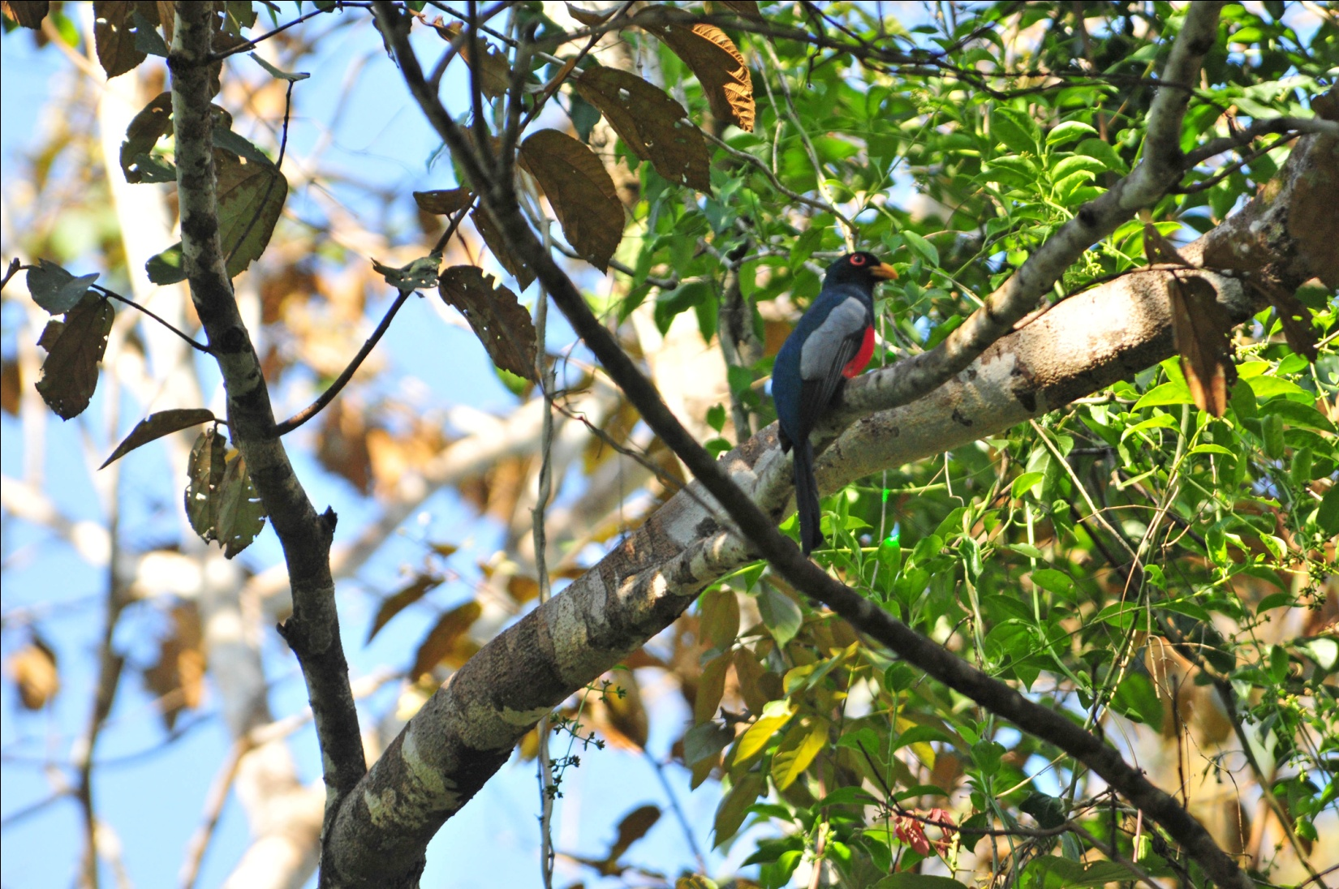
Black-tailed Trogon, female
Once at the lake, we sat down to relax a bit on the nice deck at the water's edge. It wasn't long before we were all on our feet, vying for a better look at a Snail Kite sitting on a low palm branch on the far side of the lake. Near it was a Yellow-headed Caracara, and in the palms around it we could catch glimpses of a Yellow-tailed Oriole. Common Moorhens, Purple Gallinule and Wattled Jacana wandered in and out of the aquatic plants, and we enjoyed seeing them even though they were not new for the trip.

From the pond, we walked to the observation tower, hoping to be in good position when birds, particularly parrots, began to fly in to roost for the night. Several Scaled Pigeons perched at the top of a nearby tree and some Blue-headed Parrots flew by, but not much else was seen from the tower. Several people went down after awhile and returned to the hummingbirds feeders, which had become quite active. That group got some excellent looks at Violaceous Trogon in addition to the hummingbirds. Others of the group maintained our position on the tower, waiting for something to happen, but it never did. We descended and joined the others to start the drive back to the lodge.

As we were driving down the lane to exit onto Pipeline Road, I saw some movement on a muddy bank on the right side of the road. I called to Guido to stop, and there beside us in full view (and up close) was a Scaly-throated Leaftosser. Matching the color of the earth almost perfectly, we never would have seen the bird if it had not been living up to its name, tossing leaves for all it was worth. While watching the Leaftosser, Guido heard a Black-faced Antthrush on the other side of the road. Almost everyone was able to get on the bird before we got back into the van and drove away. A splendid ending for a wonderful day!

Other species seen by the group today included Squirrel Cuckoo, Common Paraque, Southern Beardless Tyrannulet, Dusky-capped Flycatcher, Lesser Greenlet, and Semiplumbeous Hawk. We finished the day with 85 species, a total of 122 species so far for our two days of birding.

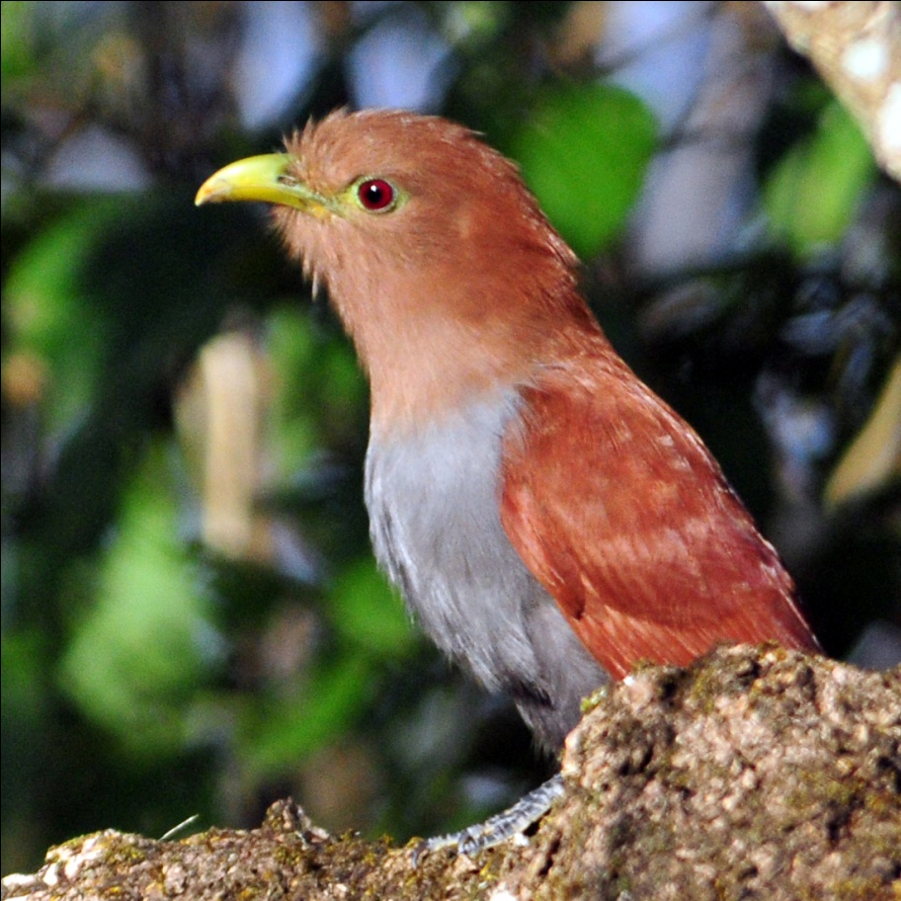
Squirrel Cuckoo
Day 4, Monday, Feb. 21: Today we traveled to and area within Chagres National Park called Madden Dry Forest. A second guide, Michael, joined us today and we learned that he would be with us for the remainder of the trip.

When we arrived at Madden, we were surprised to hear Guido say we should leave our things in the car since we would be near the parking lot for a few hours. Once we emerged from the van, however, his statement made sense. From the parking lot and on the road within a few hundred yards of the parking lot, we saw an amazing variety of birds. Greenish Elaenia, Slate-headed and Common Tody-Flycatchers, Panama Flycatcher, Masked Tityra, Squirrel Cuckoo, Yellow-throated Vireo, Yellow-green Vireo, Scrub and Golden-fronted Greenlets, Green Shrike-Vireo, Rufous-and-white Wren, Summer Tanager, Rose-breasted Grosbeak (female), Yellow-backed Oriole, Baltimore Oriole, Crested Oropendola, Yellow-crowned and Thick-billed Euphonias were all seen with little effort. Occasionally, we had to take our eyes off the trees and bushes around us to look skyward where we saw Common Black Hawk, Double-toothed Kite, and Band-rumped and Lesser Swallow-tailed Swifts.

After awhile, we pulled ourselves away from the parking lot, and I consoled myself by thinking, if the parking lot is this good, I can't wait to hit the trail! But the trail had nothing on the parking lot. It took quite awhile for us to find a few species: Yellow-olive Flycatcher, Streaked Flycatcher, Bay-breasted and Black-and-white Warblers. Only part of the group was able to get on the Rosy Thrush-Tanager. Walking back to the parking lot, a few of us were lucky to see a Thrushlike Schiffornis perched in an opening near the forest floor. But, without a doubt, the star performer of the day was the Lance-tailed Manakin. If its bright blue back and scarlet cap aren't enough to thrill you, just wait until it starts to vocalize and dance. What a remarkable bird!

We made a quick trip back to the lodge for lunch and to finish packing for our trek to the highlands. We left a bit behind schedule and then had to make a stop at the Panama Audubon Society headquarters where Guido needed to sign some papers. While waiting for him, we saw some common birds of the city, among them the Tropical Mockingbird that most of the group had not yet seen.

The drive to Santiago was pretty long, and we expected more birding stops than we actually had. As we drove near the coast, crossing the old Bridge of the Americas, we saw Brown Pelican, Neotropic Cormorant, Osprey, and Royal Tern from the van. Elsewhere on the drive we spotted a few more birds, such as White-tailed Kite, Savannah Hawk, and lots of Cattle Egrets. It wasn't until late in the afternoon that we could understand why Guido had not been stopping much. With the delay in leaving Panama City, we didn't have as much time as originally planned and he wanted to reach a favorite birding spot of his called Cienega de Macanas while we still had enough daylight to bird. The wetland and the fields surrounding it were teaming with birds: Black-bellied Whistling Duck, Blue-winged Teal, White ibis, Glossy Ibis, Limpkin, Snail Kite, Great Egret, Great Blue Heron, Little Blue Heron, Cattle Egret, Lesser Yellow-headed Vulture, Savannah Hawk, Crested Caracara, Merlin, Greater and Lesser Yellowlegs, Spotted Sandpiper, Groove-billed and Smooth-billed Anis, and Barn Swallow, all seen in short order. Driving along a dirt road to reach the wetland, we saw an Aplomado Falcon, first perched and then in flight. A beautiful mature bird in breeding plumage, it was a delight to see. Light faded too quickly as none of us had had our fill of this place, but we had to move on.

We arrived in Santiago shortly after 8:00 PM. Nearly everyone expressed dismay in having so little time to spend at the charming hotel where we stayed, but no one complained when Guido announced that we would
leave at 5:00 the next morning. On to new elevations, new adventures, new birds!

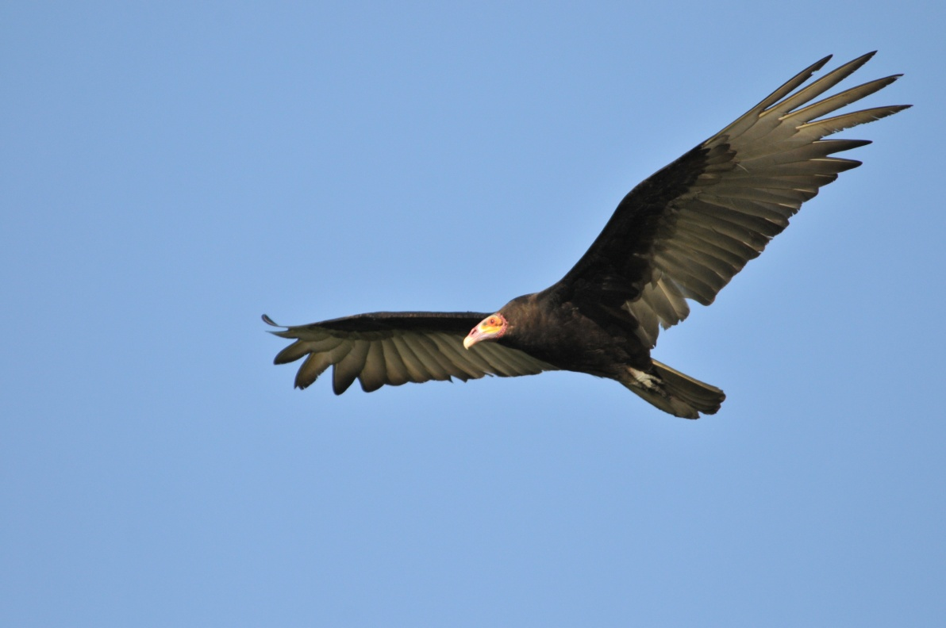
Lesser Yellow-headed Vulture
We finished the day with 101 species. With the many hours spent in transit, we were surprised that this was our highest count for the trip.

Day 5, Tuesday, Feb. 22: We didn't leave the hotel until 5:30 AM because Guido and Michael had graciously procured some breakfast items for us. The group ate cereal, yogurt, bread and jam, and had their morning coffee and orange juice by the dimly lit pool. By the time we gobbled down some food, everyone was wide awake and anxious to hit the road for La Fortuna.

Our first stop was at a small local restaurant for people to use the restroom. As we waited for people to take turns in the one-seater bathroom, we watched for birds in the trees in the parking lot and across the road. As we watched a Tropical Parula and some other warblers in the tree above us, someone alerted the group to a large bird across the street. There, alone and not calling, was a Black-chested Jay. We all enjoyed wonderful views as I chided Guido with, "Are you sure it's a Black-chested Jay? How can it be if it's alone and quiet?" and "I have it on good authority that Black-chested Jays are never alone and are always vocal." He took the kidding well, and I felt vindicated from his "wrong call" verdict of a few days earlier.

We drove for quite awhile before our first real birding stop, a privately-owned gravel road that led to a place called Batipa. We walked for over an hour there, and all agreed that it was an excellent stop. Some of the birds seen included Lance-tailed Manakin, Mangrove Cuckoo, Black-hooded Antshrike, Barred Hawk, Brown-throated Parakeet flyby (first of many), Long-billed Starthroat, Spotted Woodcreeper, Pale-eyed Pygmy-Tyrant, Ruddy-tailed Flycatcher, Bright-rumped Attila, Gray-capped Flycatcher, Philadelphia Vireo, Blackburnian Warbler, Orange-billed Sparrow, and Black-striped Sparrow.
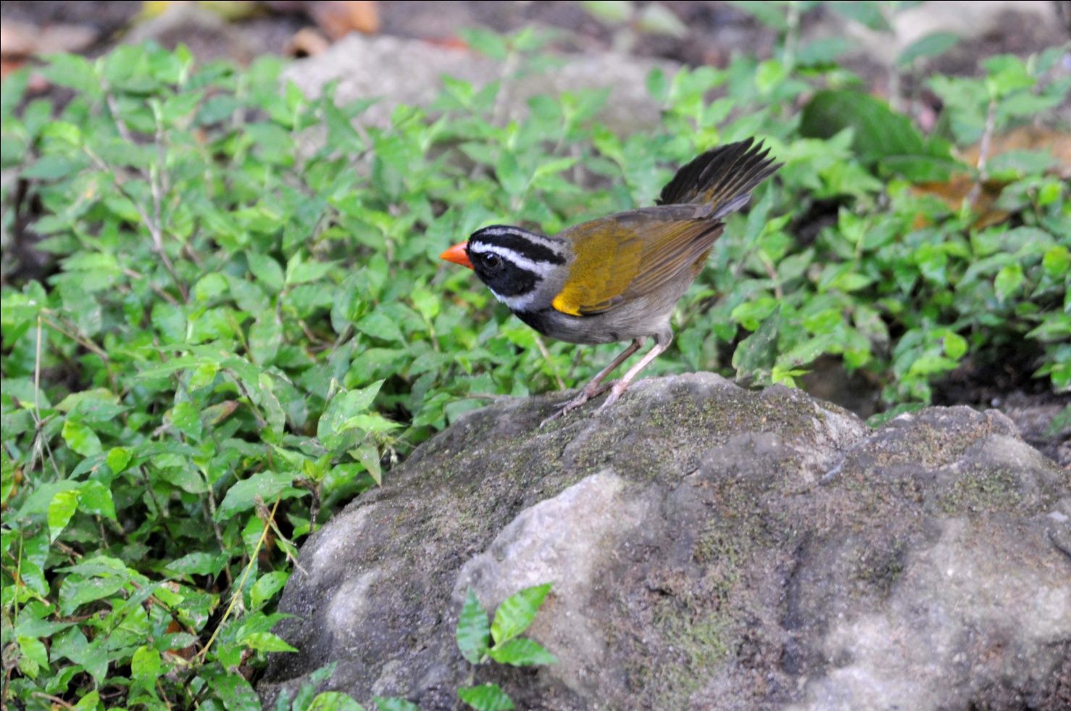
Orange-billed Sparrow

Back in the van for another substantial drive before we came to a bridge on Fortuna Road. The first bird sighted was a Black Phoebe sitting on a rock in the stream below. It caused a bit of confusion for a few moments as no one remembered that the Black Phoebes in Central America have much less white on their lower bellies than those we are accustomed to seeing in the US. Looking down from the bridge, we watched a hummingbird as it repeatedly flew out from its perch and then retreated back into the cover provided by the bushes at the stream's edge. After many glances of this uncooperative little hummer, Guido finally saw enough field marks to peg it as a Green-fronted Lancebill. As we were watching this hummingbird, one person in our group spotted an American Dipper as it zipped by and headed downstream out of sight. We also saw a Blue-throated Goldentail at the bridge, but the best sighting here was undoubtedly a mature Ornate Hawk-Eagle in breeding plumage. Sitting in a tree on a ridge in the distance, we had excellent scope views of the most "ornate" Hawk-Eagle I've ever seen. It's colors were bold and its crest impressive. We watched as it flew from its perch and circled in the air above us. Another great look at a magnificant raptor, both perched and in the air!

At midday we arrived at Palo Deco Reserve, where we had lunch at a small roadside restaurant. The food was delicious, but I think we all wondered if we should be eating the salad at an establishment like this. (We all ate it, and no one got sick.) In front of the restaurant, we saw Swallow-tailed Kite and White Hawk soaring in front of the nearby forested hill. Several Dusky-faced Tanagers and Tawny-crested Tanagers moved about in the bushes and trees along the road. Stripe-throated Hermit and White-bellied Mountain-gem visited the flowers near the restaurant. At least one Mourning Warbler was seen. After eating, we walked a short way to an overlook that is normally very productive, but didn't get much action there. After a short time, Guido
decided we should move on. We had barely gone a quarter of a mile when something attracted his attention and he pulled over to the side of the road. There, we enjoyed watching one species after another appear in the trees that lined the ridge. We felt like kids in a candy store as we enjoyed the spectacle before us: Ochre-bellied Flycatcher, Tropical Pewee, Long-tailed Tyrant, Boat-billed Flycatcher, Cinnamon Becard, Golden-winged Warbler, Common bush-Tanager, Crimson-collared Tanager, Emerald Tanager, Bay-headed Tanager, Scarlet-thighed Dacnis, Olive-backed and Tawny-capped Euphonias.

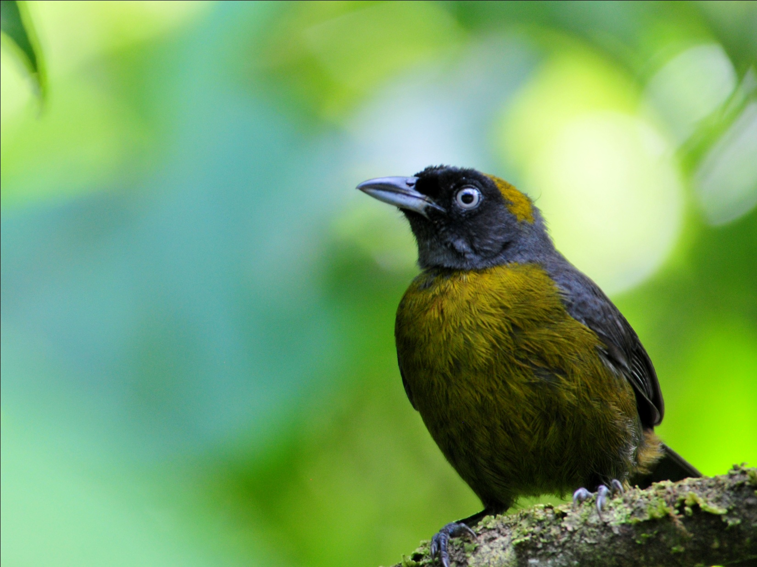
Dusky-faced Tanager

We made a brief stop at a small house where we had been invited to see some feeders. The house belonged to a relative of the woman who ran the restaurant. The feeders weren't too active at this time of day, but we did spot a Green Hermit feeding on Hibiscus as we walked down the path to return to the van.

We crossed the Continental Divide and took a short detour on a paved side road. There, we saw Broad-winged Hawk, Band-tailed Pigeon, Chimney Swift, Mississippi Kite, Black-cheeked and Golden-Olive Woodpeckers, Blue-and-White Swallows, and Thick-billed Seed-Finch. A few people in the group saw Blue-and-gold Tanager. Traveling across the Continental Divide made it possible for us to observe both Passerini and Cherrie's Tanagers in the same day. As we were driving away, Guido came to an abrupt stop because he heard Azure-hooded Jays. The birds responded to the taped calls, and we all had excellent views of them.

We arrived in David at around 7:30 PM and quickly made the decision to eat at a cafeteria next door to save some time. After dinner, we met in the business center to go over our day's list. We finished the day with 96 species, many of them new for the trip.

Day 6, Wednesday, Feb. 23: We left the hotel at 6:30 AM and made a stop at a nearby cafeteria for breakfast before heading for Volcan. As we were eating, we observed several groups of Red-crowned Parrots flying over. A group of Baltimore Orioles landed in the trees across the street, as well as Orange-chinned Parakeets. Another quick stop to buy ice forced us to include House Sparrow on our list, much to my chagrin.

Our first stop was near Cuestra de Piedro, where we drove down a paved road into a valley where a small stream runs through a deep gorge. The bird activity was obvious as soon as we stepped out of the van. Cherrie's Tanagers, both males and females, were abundant. Lesser Goldfinch sang from the top of a conifer, while Snowy-bellied and Charming Hummingbirds flitted from tree to tree. White-collared swifts soared overhead and Crested Oropendolas flew by, the yellow in their tails lit by the early morning sunlight.

Near the stream, we spotted Buff-rumped Warbler, Silver-throated Tanager, and Spot-crowned and Thick-billed Euphonias. Louisiana Waterthrush bobbed along the bank and a Golden-winged Warbler alit briefly in front of a few birders. Green Kingfisher hunted from its stone perch above the water near a Black Phoebe. A Spotted Barbtail inched its way along the trunk of a tree as an Ochre-bellied Flycatcher called from above. A Brown Violet-ear drew a lot of attention from our group as it hawked insects from a low perch near the road. In the tree above the Violet-ear, a Yellow-bellied Tyrranulet called - a life bird for our guides! Its close relative, Paltry Tyrannulet, was also seen in the area. A Rufous-breasted Wren provided not only its delightful song, but also granted us some good looks at a member of this difficult-to-see family.

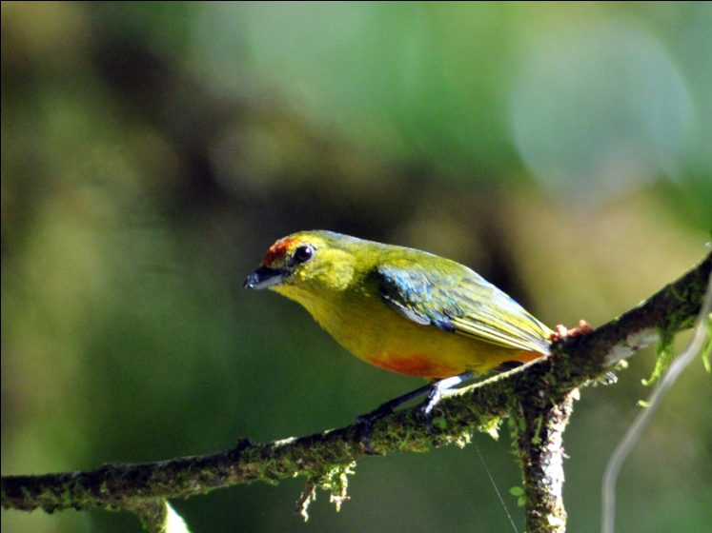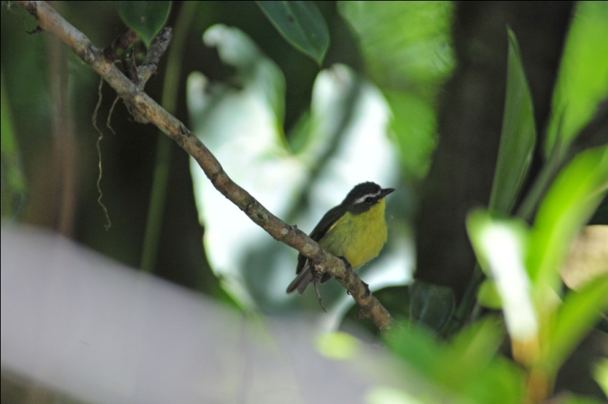
Spot-crowned Euphonia, female Yellow-bellied Tyrranulet

It was difficult to leave this lovely spot - it felt like a good place to just spend an entire day. But we moved on to the top of the ridge where we had good views of the hillsides and valley below. From this ridge, we saw a White-crowned Parrot perched on a treetop on the hillside below us, providing excellent scope views for all of us. A Roadside Hawk flew by, calling as it alit on a branch near the parrot. Overhead, we saw both light and dark morphs of Short-tailed Hawk circling. In a low bush at the edge of the road, a Pale-bellied Spinetail called incessently. We watched it through the branches as it called. It was still calling when we drove back past the area a short while later. We stopped one last time in the area where we started, walking a very short trail that led back to an observation point for the gorge. Along this trail, we got some good looks at White-ruffed Manakin.

We next went to our hotel, Dos Rios, in Volcan. Our rooms were not ready yet, so we birded around the lodge for a few minutes while we waited for our pizza lunch to be prepared. Birds seen in this short time included Wilson's Warbler and Elegant Euphonia. When we were told that they needed more time to prepare our rooms after we had finished lunch, we decided to go to the nearby coffee plantation to do a little birding there. At the Jansen Family Coffee Plantation we observed Streaked Saltator, Bananaquit, Yellow-faced Grassquit, and Scintillant, Snowy-bellied, and Rufous-tailed Hummingbirds. Norma saw a Mourning Warbler as it zipped under a bush. Only a few of us had seen the very common Rufous-collared Sparrow up to this point, an attractive little bird that Guido referred to as "Trash Bird" because it is so abundant. As we were standing outside the coffee store, a sparrow flew by and Michael thought it was a House Sparrow. I looked through my binoculars and said he should look because it wasn't a House Sparrow. Although an accomplished birding guide in the Canal Zone, this was Michael's first trip to the highlands and he had never observed this species before. When he got the bird in his binoculars, he exclaimed, "Ooh! That's no trash bird! He's pretty!" Just one example of why our group enjoyed Michael so much on our tour. He had the expertise of an experienced birding guide with the innocence and enthusiasm of a beginning birder. What a combination!

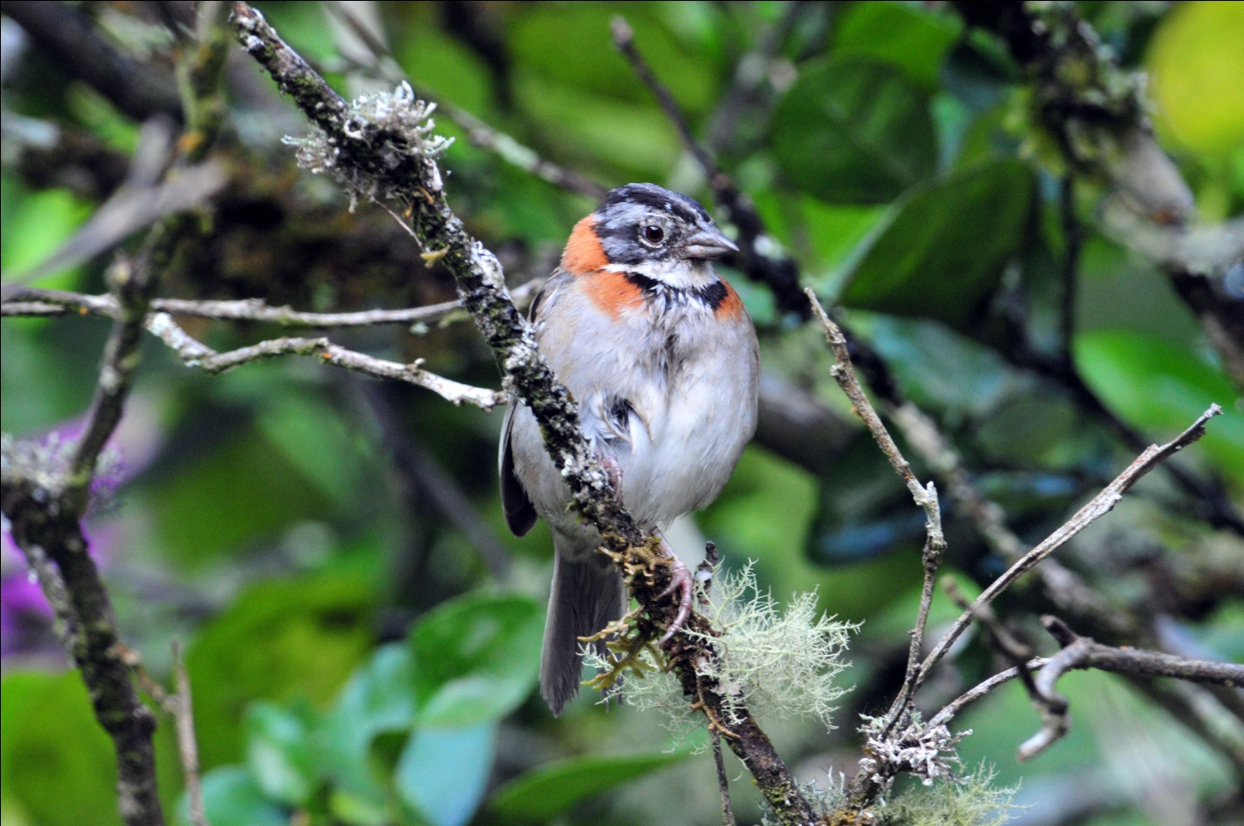
Rufous-collared Sparrow
As we drove back to the hotel, we saw Fork-tailed Flycatcher and heard Eastern Meadowlark along the private runway that leads to the exit road. Guido slowed down as we passed the marsh near the hotel so everyone could see the field marks on Least and Pied-billed Grebes.

After checking into our rooms at the hotel, we took a short break and then headed to Volcan Lakes, part of the Jansen Family estate. As we started on our walk, rain threatened to fall for the first time since we began the trip. I kept taking my long-sleeved shirt on and off in sync with the sun's emergence from clouds. Although a few sprinkles fell, we made the entire walk without getting wet. The trail leading to the lake was more quiet than normal, and we saw fewer birds there than I have on previous trips. White-tailed Emerald, Olivaceous Woodcreeper, Slaty Antwren, Slate-throated Redstart, Golden-crowned and Rufous-capped Warblers were all new for the trip. We came upon a Yellow Warbler, which I had missed when the group saw one on the first day.

At the lake, we added Green Heron, American Coot, Blue-black Grassquit, and Northern Jacana to the trip list. A Scaled Pigeon posed on a distant treetop, allowing good scope views for those who missed it from the Discovery Center Tower on Day 3 when they opted to go down early to watch the hummingbird feeders. I had been hoping to see the Masked Ducks that had been reported at the lakes for the last few weeks, but none were found.

As we walked back down the trail, we could hear a Green Hermit's nonstop calling. The bird was sitting on a twig and remained stationary as everyone viewed it through the scope. Not a trip bird, but wonderful to see as its whole body jerked each time it called out. The light was very low by now, but we managed to get a couple of marginally-acceptable photos through the scope.

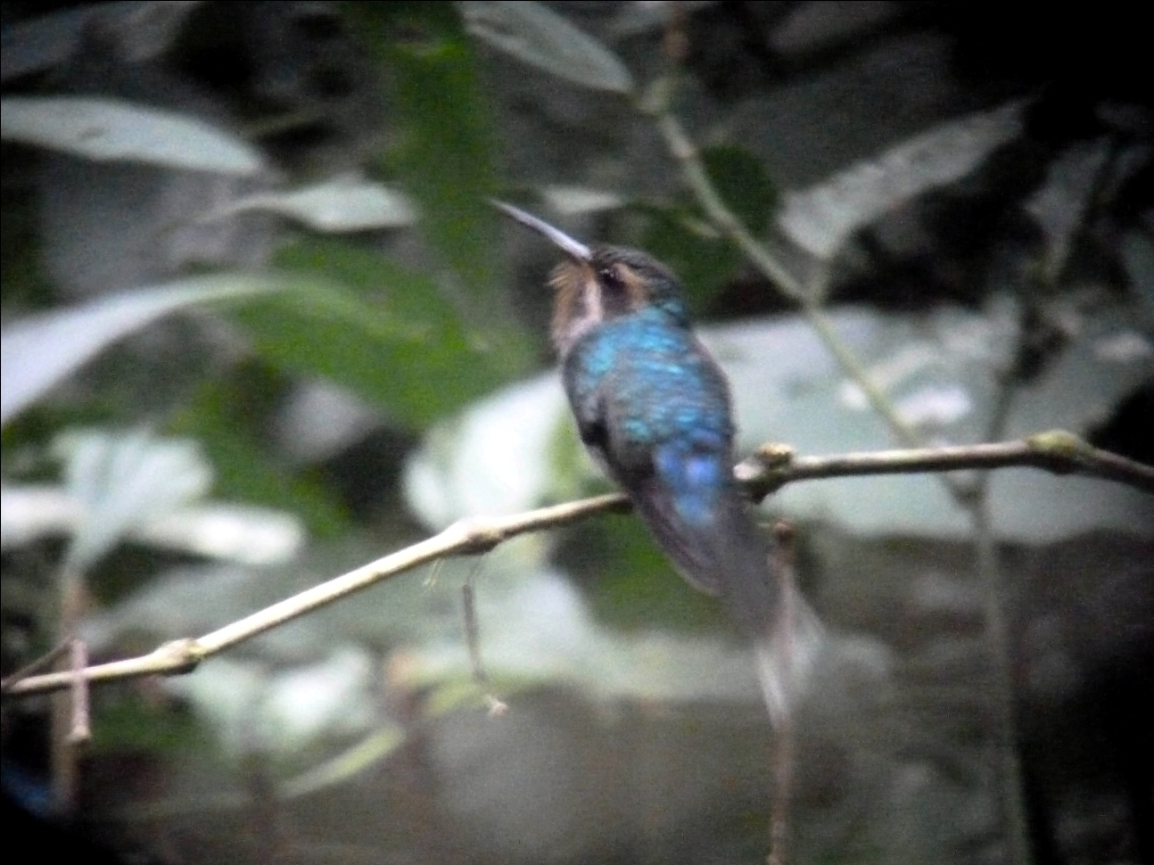
Green Hermit
Just as we were getting into the van, the rain began. We drove back to the hotel, arriving in time to allow us to finish our checklist before dinner. Our first day in the Volcan area yielded us 101 species, with a total of 265 for the trip so far. We challenged ourselves to reach 300 the next day. With La Amistad International Park on our schedule, it seemed like a reasonable goal.

Day 7, Thursday, Feb. 24: Everyone was willing to get out of bed at whatever hour to make the most of our day at La Amistad, but Guido gave us a pretty reasonable schedule. We would leave at 6:30 and have breakfast at the park. As we arrived at the park, we positioned ourselves on the porch of a tiny cafe situated just inside the entrance. The ladies running the cafe served us hot chocolate and coffee as we watched Yellow-thighed Finches and Chestnut-capped Brush-finches hop around in the foliage below. Magnificent Hummingbirds competed with White-throated Mountain-gems for positions at the feeders positioned within an arm's length of us. Mountain Thrush and Ruddy-capped nightingale-Thrush appeared on the scene, and a few of us saw Slaty Flowerpiercers. I know most people were thinking a breakfast on the trail would leave a lot to be desired, so when we were served a piping hot breakfast of eggs and freshly made fry bread, everyone was pleasantly surprised. As we left the building to begin our day of birding in earnest, we saw Flame-throated Warbler and Yellow-winged Vireo in the trees opposite the cafe.

Guido drove us up to the next level, where a shelter and some restrooms are located. We worked hard to see a Rufous-browed Peppershrike, and everyone was rewarded with stunning views. Also in the area around the shelter was Yellowish Flycatcher and Spot-crowned Woodcreeper. A molting Flame-colored Tanager made us pause for a moment to decide if it could possibly be a Western Tanager, but its call confirmed Guido's initial id.

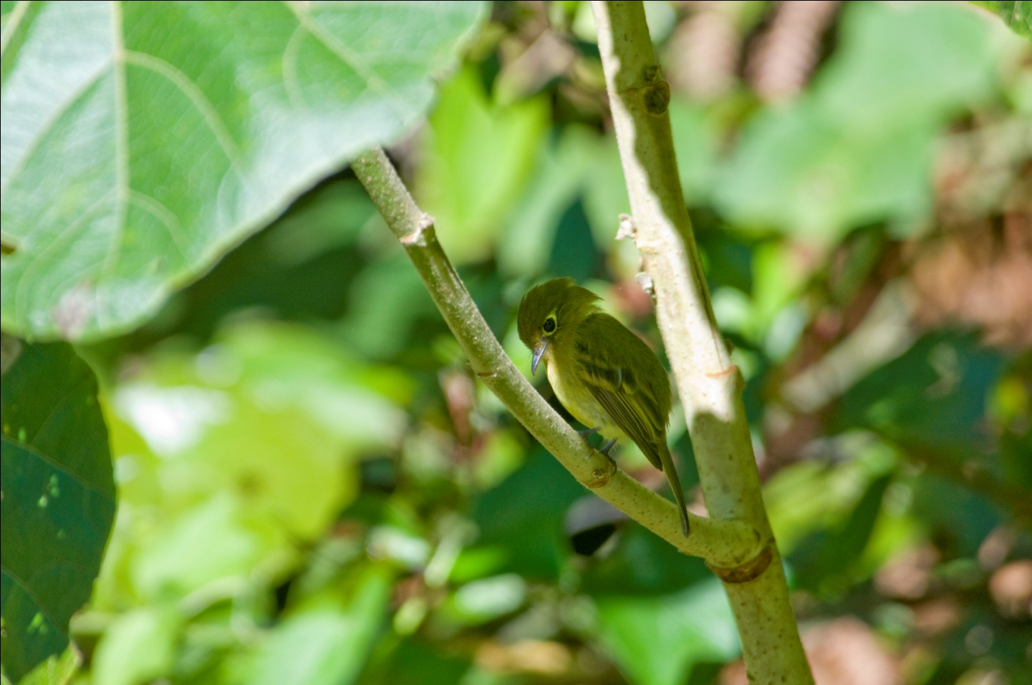
Yellowish Flycatcher
We left the clearing and began walking uphill along the trail. We were, of course, hoping for a Resplendent Quetzal here, but none were heard as we continued up the hill. New birds were added as we walked: Collared Redstart, Tufted Flycatcher, Black-cheeked Warbler, Buffy Tufted-cheek, Ochraceous Wren, Lesser and Mountain Elaenias, Ruddy Treerunner, and we got better looks at Flame-throated Warbler. Black-billed Nightingale-Thrush and White-throated Thrush were seen and compared to their counterparts we had seen earlier. Michael and Jim, while lagging behind for a better look at one of the birds, spotted a Yellow-bellied Sapsucker. At one point, Michael was looking into the forest, imitating perfectly the bird song that was coming from deep within the greenery. I asked him what bird it was, and he responded, "I don't know. It's the first time I hear it." I was continually amazed by his ability to imitate bird song, but never did I imagine that he was able to learn a new vocalization on the spot like this. The trail continued at a pretty steep incline and the footing began to get rougher until we reached a level clearing. Here, Michael found a Prong-billed Barbet and was able to get every birder on it before it flew away. We had heard the vocalizations of Black-faced Solitaires for most of the walk, and it was here that I got a good view of one with its bright orange bill. As I was directing people to its location at the top of a tall tree, it shot downward and out of sight.

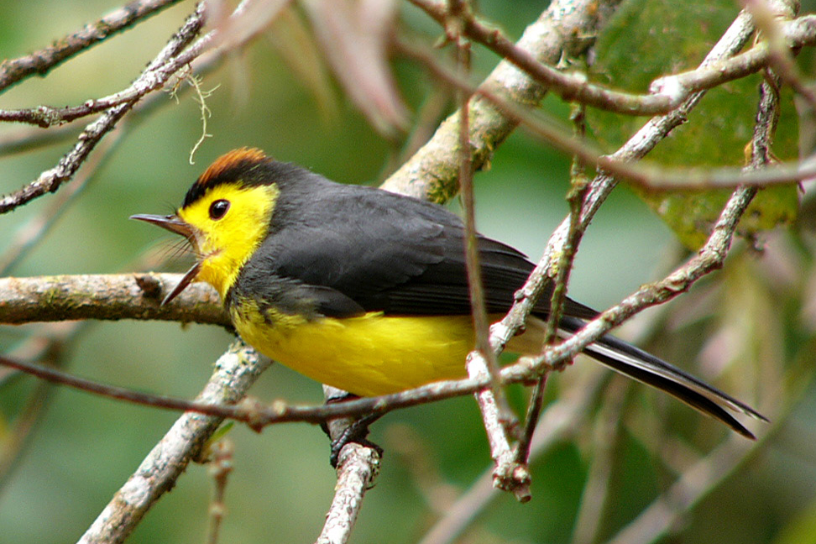
Collared Redstart

As we started to walk farther up the trail, Norma and Dale made the decision that they would begin their descent and meet us back at the shelter at mid-level or at the cafe near the entrance. We didn't go much further, but we managed to find Ochraceous Pewee and Black-and-Yellow Silky-Flycatcher before turning back. As we reached the clearing again, Michael once again imitated the call of the Resplendent Quetzal. This would be a life bird for him, and he didn't want to miss the opportunity to see this magnificent creature. We picked up some Sooty-capped Bush-Tanagers as we waited for the Quetzals to respond, but we heard no sound that could be our target species. Coming back down the hill, we had good looks at a male Barred Becard and a chance for better looks and photo ops of a Collared Redstart.

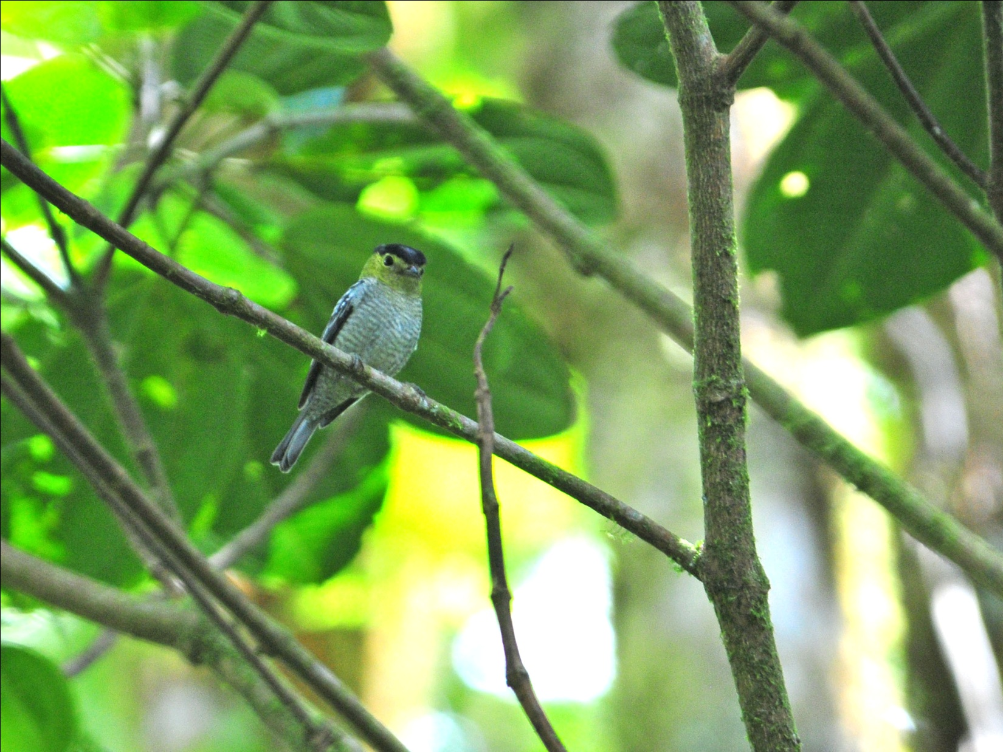
Barred Becard
When we got back to the shelter at mid-level, Guido went to talk to the park ranger as we lined up for restroom privileges. Before everyone could get out of the restroom, he came running back, telling us to get in the van quickly - QUETZAL! Everyone piled in as fast as we could and as we took off, he explained that the ranger had told him that a couple of birders were looking at a Quetzal a short distance down the road - just five minutes ago! We drove all the way down the steep hill but saw no birders. I said, "Wouldn't it be cool if the birders were Dale and Norma?" but the ranger had made it sound like it was two guys rather than a couple. We made it all the way down to the cafe without finding the birders with the quetzals, but Dale was there to tell us that he and Norma were, in fact, the birders we had been looking for. We took off on foot, following Dale back to the spot where he and Norma had been watching the female quetzal. Norma was in the restroom of the cafe, so I stayed back for a few minutes to let her know where everyone went. It was much farther up the hill than Dale had originally had thought, but we all made it in pretty good time. We looked and looked in the area where the female had been, which was near an old nest tree. Knowing that the male would be nearby if a female was around, we hopefully scanned and rescanned every tree within our range of vision. Finally, Guido spotted it. Not the best looks ever, and not a male, but a Resplendent Quetzal nonetheless. It sat perfectly still, in fairly good light but too far to even attempt a photo. We left the spot satisfied that we had seen our target species, but wanting more.

We enjoyed a hearty lunch at the same cafe where we had breakfast, now warmed up and seated on the deck outside where we could watch birds as we ate. The hummingbird feeders were even more active now, with a lot of birds coming very close. One Magnificent Hummingbird practically flew into Guido's mouth as he was taking a bite of food! The Dark Pewee that was missed by some at breakfast appeared for all to see during lunch. Before we left La Amistad, we stopped at the bridge just outside the entrance to look for American Dipper. It took less than three minutes for the birds to be found.

On the drive back to Volcan, we picked up a few new species - Red-tailed Hawk and Mourning Dove. Our next stop was at a lovely Bed and Breakfast on the outskirts of Volcan called Cielito Sur. We had visited this spot in 2010 because it had rained so hard at LaAmistad that we left early. The birds at the feeders and in the gardens were so good that this year we requested a stop. It began to rain just before we got there, but this is a perfect location for rainy-day birding. Covered verandas surrounded by hummingbird feeders - what more could you want? Some new hummingbirds to our trip, Violet Sabrewing and Green Violet-ear were the most numerous at these feeders. A few Stripe-tailed Hummingbirds, also new for the trip, were among the more abundant species, as well as some hummers we'd already seen: Magnificent, Snowy-bellied, Rufous-tailed, and White-throated Mountain-gem.

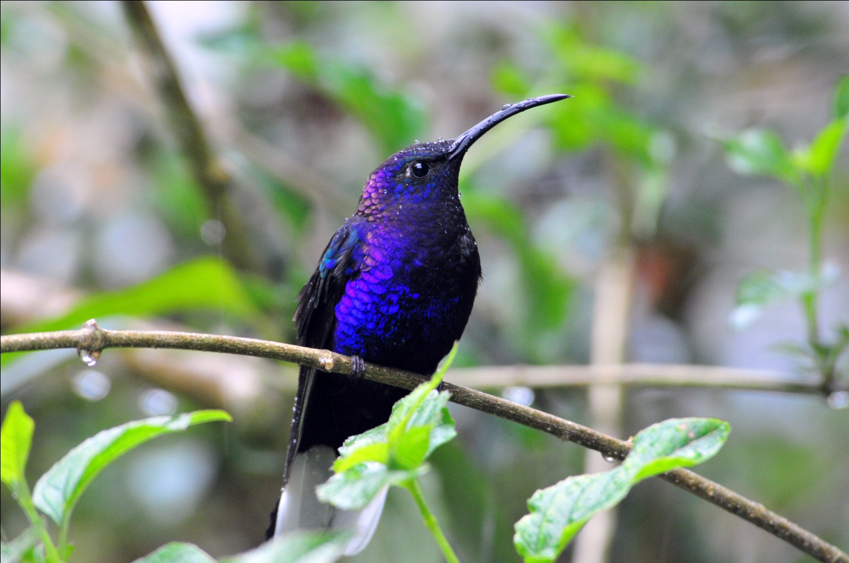
Violet Sabrewing
Our final stop for the day was at Bambito Lodge where Torrent Tyrannulets are resident in the series of ponds in the hotel's front garden. The ponds are connected by small waterfalls, perfect habitat for the tiny gray birds. It was still raining lightly when we were there, but that didn't stop the timed irrigation system from watering the lush lawns as I tried to make my way to a better vantage point for a photo of the tyrannulets. I tried to time my advances through the intermittent spray, but found myself doused more than once.

The rain stopped as we arrived at Dos Rios and some of our group went to bird the gardens there. They added Blue-diademed Motmot and Orange-billed Nightingale-Thrush to the trip list. Since the Nightingale Thrush would have been a lifer for me, I regretted using my time to check emails that afternoon.

As we were birding today, Guido was in contact with birders at the other side of the Las Quetzales Trail. He learned that many quetzals, both male and female, were being seen in fruiting trees there, and he offered a change in plans to allow us to take advantage of this opportunity. We would bird Baru Volcano National Park in the morning as planned, but instead of going to David for an afternoon flight back to Panama City, we would drive to a new lodge near Boquette called the Rio Cristal Lodge. We would then spend the night there and drive to David the following morning to catch an 8:00 AM flight back to Panama City. We would still have the remainder of the final day to hit some of the spots we missed in the Gamboa area and revisit Pipeline Road. Since we were not prepared for the extra day, he said the hotel could have laundry done for us by the time we returned at noon for lunch, before we drove on to Boquette. The group unanimously agreed that we should accept the change in itinerary.

When we went over our checklist that evening we found we had seen just 73 species, our lowest daily count for the trip so far. Because so many of the species were new for the trip, it hadn't felt like a slow day at all. And our goal to reach 300 species today? Achieved, with 5 species to spare!

Day 8, Friday, Feb. 25: We departed the hotel for Baru Volcano National Park fairly early so we could have breakfast at a lovely Bed & Breakfast near the park. Owned and operated by a family of second-generation Chinese immigrants, Las Orchideas is beautifully situated with a stream running through the property. We enjoyed our breakfast with Magnificent Hummingbirds and Slaty Flowerpiercers right outside the open windows, and then gathered to begin our day's birding in Baru. As we were boarding the van, we spotted a male Yellow-bellied Siskin on the wires in front of the building. We would see other siskins before leaving the highlands, but this was the only male seen by the group.

When we arrived at the entrance to Baru Volcano NP, the first birds we saw were Long-tailed Silky-Flycatchers. Positioned atop a tree in the distance, we had perfect views of these beauties. A tree nearby harbored Acorn Woodpecker. We walked a short distance and ran into another birding group in front of a house owned by a board member of the Panama Audubon Society, where Guido told us he has seen many quetzals on previous trips. With the trees not in fruit, no quetzals were around. In the trees in front of this house we saw Rough-legged Tyrannulet, Brown-capped Vireo, and "Dirty Harry", the dark version of Hairy Woodpecker found in Panama.

Along the trail, we heard Silvery-fronted Tapaculo, a secretive species that is more often heard than seen. Michael spotted it first, and then spotted it several more times, but much of the group was unable to get on the bird. Luckily, it flew and landed right in front of me while I was trying to follow the sound.
On our walk up the main trail at Baru we saw many of the species we'd already seen on the trip, something that most of us enjoy because it allows us to "test" ourselves and learn the birds better. New birds included Ruddy Pigeon, Volcano Hummingbird, Blue-throated Toucanet, Red-faced Spinetail, Lineated Foliage-gleaner, Plain Wren, Black-throated Green Warbler, and White-naped Brush-finch. But the best bird here was not new to the trip, unless its gender counts. Standing on the trail looking for something else (I don't remember what), I caught some motion out of the corner of my eye. Before I could say a word, Michael called out excitedly. He had seen a male Resplendent Quetzal fly across the path and into the trees. It took only a few minutes for Guido and Michael to relocate the bird and get it in the scope. Wow! Over half of our group had never seen a male Quetzal, and we basked in the wonderful moment with them.

We left Baru at around 11:30 and headed back to Los Orchideas for lunch. Hoping for a Chinese meal, we were not disappointed - Sweet and Sour Chicken and Broccoli and Beef were served with a mound of sticky rice. Either of the two main dishes served would have been enough for lunch, but we were each given an ample portion of both entrees. Ice cream for dessert, and we were off to gather our things at Dos Rios and head for the other side of the volcano.

On our way to Dos Rios, Michael pointed out some Bronzed Cowbirds at horse farm. We grabbed our things as quickly as possible and headed down the road where we had first birded on Day 6, near Cuestra de Piedra. As we rounded the curve at the bottom of the valley, Roseann and Michael saw a Gray-necked Wood-Rail from the van. Further along, we stopped when Guido heard the call of a Striped Cuckoo in a farm field. We got out of the van and walked toward the calls. As soon as everyone had seen the cuckoo, we hurried back to the van to continue on to Boquette. Guido was trying a new route, and he didn't know exactly how long it would take to get there. He took a wrong turn, and then we got into heavy traffic going through Boquette, but we made it to Rio Cristal with plenty of daylight left.
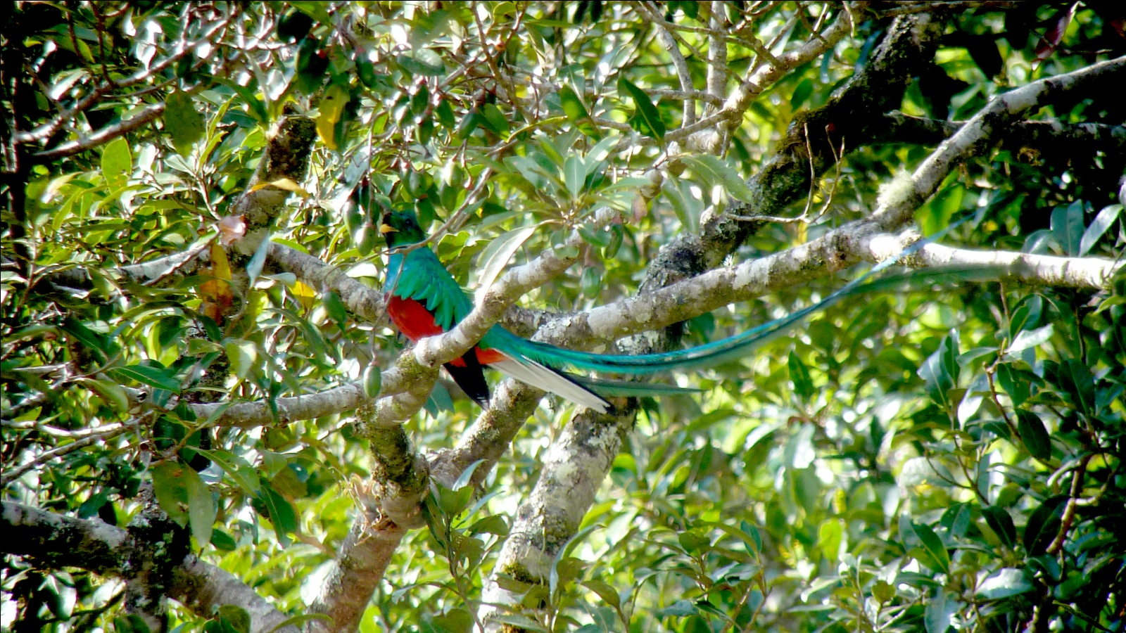
Resplendent Quetzal
Some workers told us the Quetzals had just been in the trees in front of the cabanas, but the birds were now nowhere to be seen. The manager came out and offered to show us another tree he knew of that was in fruit. We followed him a short distance up a trail alongside a wide ravine. On the other side of the ravine was an avocado tree full of ripe fruit. There, much to our surprise and delight, were at least six male Resplendent Quetzals and at least three females. Long lustrous tails blowing in the wind, brilliant colors lit by afternoon sunlight, nothing like I've ever seen. The only thing that would have improved this vision would have been a narrower ravine so that we would have been close enough for good photos. A couple of us struggled to try to take some shots through the spotting scope, but no one had the equipment to do it properly. No matter, the picture in my mind is permanent.

Coming back down the hill toward the cabanas, someone spotted a Golden-browed Chlorophonia. First a female, then a male flew into view. It soon became apparent that they were building a nest and we were able to approach fairly close for photographs. I've never had such good looks or such long looks at this species, and I was almost as impressed by these little birds as I had been by the Quetzals.
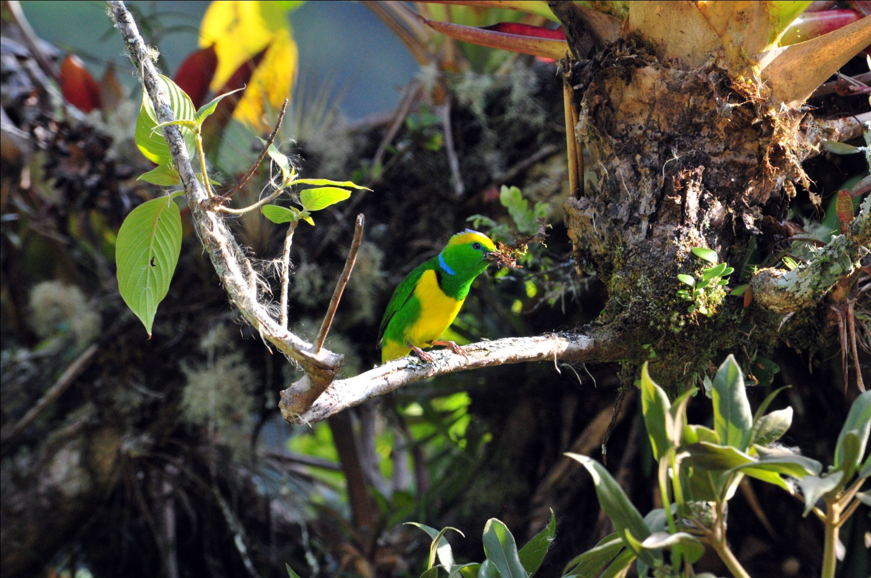
Golden-browed Chlorophonia

Part of the group relaxed on the porches of their cabanas with a glass of wine or soda while others walked with Michael and Guido in search of new species. I started with the birders but returned to the cabanas after a short time. Later in the evening, some of our group went out in search of owls, but I did not. Most of the group was able to see a Barn Owl. Not counting the owl, which would be added to the list tomorrow, we had seen 77 species today. We agreed to leave in the morning at 5:30 so we would have a little time to bird around the airport before checking in for our flight.
Day 9, Saturday, Feb. 26: Everyone was ready to go at 5:30, but the manager at the lodge had graciously arranged for our breakfast before we departed. It took an extra half hour, and then we were on the road by 6:00. We arrived at the airport shortly after 7:00 AM and saw long lines at the counter. We had opted to leave all of our luggage with Michael to bring back to Gamboa with the van, so all we had was our carry-on items. We turned our passports over to Guido, who took them inside and started the check-in process for the group. He hurried back out to the van and told us we had 20 minutes to find some birds.

And find some birds we did: Brown-throated Parakeet (finally perched instead of a fly-by), Yellow-crowned Amazon, Red-lored Amazon, Great Crested Flycatcher, Black-hooded Antshrike, Blue-Black Grassquit (doing his "Johnny Jump-up" moves), Mouse-colored Tyrannulet, , Wattled Jacana, Green Heron, Yellow Warbler, Orchard Oriole, Baltimore Oriole, Red-legged Honeycreeper, Mangrove Warbler, Veraguan Mango, all in about 18 minutes. We knew we were taking more time than we should, but we just had to take a few minutes to get a better look at a Pearl Kite perched in a nearby tree. I shot off a few frames, and we all rushed back to the van. Guido drove quickly to the front of the airport and we all climbed out, leaving Michael with the van and our luggage to drive back to Gamboa. As I walked through the door, someone handed me my boarding pass, and we joined the line going through security. As soon as we made it through security, we walked out and boarded the plane and we were airborne within a few minutes. Talk about having no time to spare!
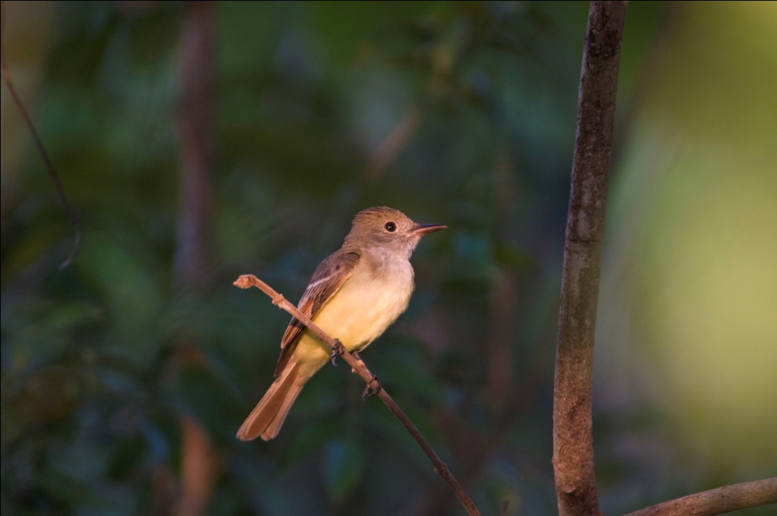
Great Crested Flycatcher

We landed in Panama City about an hour later, where we boarded a nice mini-bus to head for Gamboa. We stopped by Guido's to get a scope (ours was with Michael), and then off to Pipeline Road. It had rained the night before, and the atmosphere on Pipeline was much different than it had been just a few days earlier. Hot, muggy, muddy, buggy - more like I expected here. Birding was slow, partly because of the weather, partly because of the late start, and probably a little because of the worn state of the birders by this time. I personally missed a lot more birds than usual because I was applying mosquito repellent, taking the legs off my convertible pants, drinking water, eating snacks, etc. etc. instead of focusing on the task at hand.
Northern Scrub Flycatcher, Olivaceous Flatbill, Black-tailed Flycatcher - all new trip birds, all missed by me. We did see the Tamandua on the way out, this time in a tree.
We went back to Guido's lodge in Gamboa for a late lunch; Jesus had everything ready for us when we arrived at around 1:30. After a short break, Michael arrived from his long drive from David, and we left to hit some of the birding spots in the area that we had thus far not visited. As we drove, Guido and I discussed the fact that we were missing some very common birds on our list, most notably Rusty-margined Flycatcher (!) and Collared Aracari. Our first stop was at Summit Gardens, where an excellent exhibit on Harpy Eagles can be viewed along with a captive eagle. In front of the exhibit building, Guido took some time to identify one of the flycatchers present as a Rusty-margined Flycatcher. I was skeptical, since we had just been talking about it, but he was adamant and Michael agreed. We went on into the exhibit and enjoyed seeing the short video and the many displays showing relative size and other statistics about the Harpy Eagle. The captive bird is a male, and does not quite live up to size expectations after going through the exhibit, but a beautiful sight to behold nevertheless. Before we could get any photos of the Harpy, Guido heard a Collared Aracari calling nearby. In light of the fact that this was a bird we should have already had and that this would be our last chance, we all forgot about the eagle and rushed back to the front of the building, following the call. As we were looking for the Aracari, the Rusty-margined Flycatcher called, thus confirming the id. We finally spotted the target bird in a bare tree, but we didn't have the scope with us for better views. We walked a short distance to an area where Chestnut-headed Oropendolas nest and watched them and the Giant Cowbirds that were trying to parasitize their nests. As we walked further, we saw Northern Waterthrush, another trip bird.
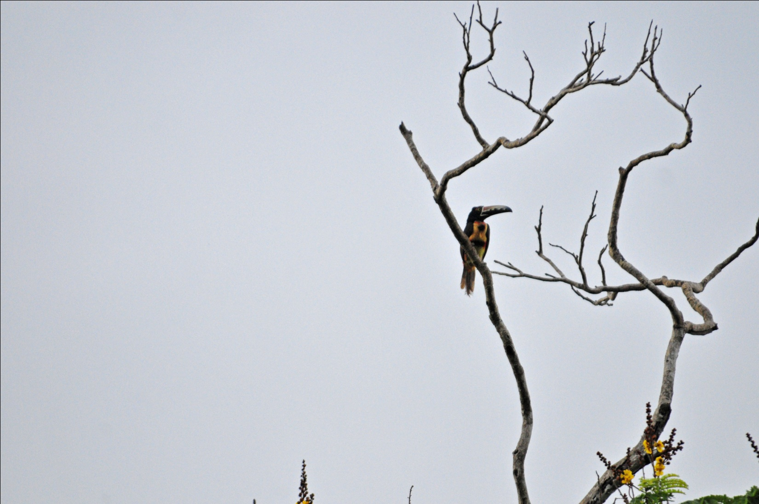
Collared Aracari

Next we visited the nearby Summit Ponds, where Boat-billed Heron are normally easy to find. Today we saw more Boat-bills than I've ever seen there, and two of them were gathering nesting material. Everyone had great views through the scope. From the area near the ponds, we also saw Green and Belted Kingfishers, the latter a new species for the trip. Guido told us that the public no longer has permission to walk the trail where we have seen Spectacled Owl on every previous trip since the Canal Authority has imposed restrictions on the area due to its proximity to the new locks that are under construction. We saw others walking the path, and ventured a short way ourselves, mainly because we heard reports that a Rufous Nightjar that had been seen there on our last visit in April was still (or again) in the area. On our way to see the nightjar, we also saw Yellow Tyrannulet, Great Antshrike, and Jet Antbird.

From here, we had intended to check out a stream behind a police station in Panama City where we usually find Cocoi Heron, but we were running out of time. We drove to the Causway instead, where we saw Laughing Gull and Royal Tern on the drive across the causeway and Sapphire-throated Hummingbird in the trees near the parking area. As the light grew dimmer and dimmer, the Two-toed Sloths in the area began to move around. We were thrilled to see the balls of fur we had been seeing for the last several days show arms and legs as they moved relatively quickly (for a sloth, anyway)through the trees overhead.

We proceeded to the Miraflores Locks where we were to have a buffet dinner overlooking the locks. It was so dark by the time we arrived that the views of the canal were not the best, and we felt pretty scraggly in our birding attire amid the posh restaurant and wedding guests. The dining room was very noisy, so we didn't try to complete our checklist until we got back to Gamboa - 106 species today, the highest daily tally for the trip, in spite of time spent on a plane! What a great way to end a fabulous birding trip!

Day 9, Saturday, Feb. 26: This morning, Guido and the Bonds left at 4:30 AM for one extra day of birding while the rest of the group departed Panama for home. Guido took Roseanne and Gloria with the Bonds at 4:30 and dropped them off at the airport on their way to the Torti area to bird in San Francisco Preserve. Michael took the Wendts to the airport next, and then came back to pick up the Sadlers for a stop at a market before taking them to the airport for their afternoon flight. Jim and I were the last to leave, and our flight was delayed to make our departure even later than planned. We ended up missing our connecting flight to Cincinnati and had to spend the night in Miami. Not the best way to end a trip, but a little bit of inconvenience is well worth it for the birding opportunities in Panama. I can't wait to go back!

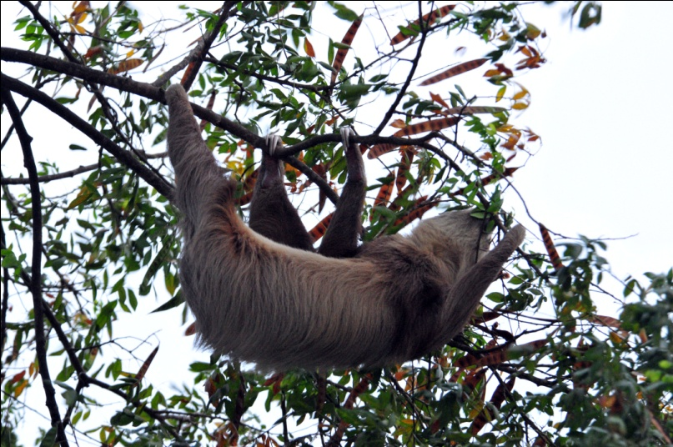
Cheepers! is offering this tour again in January 2012, as well as a trip to the Canopy Tower and Canopy Lodge in Panama in April of 2012. Please check our website for details and pricing.

www.cheepersbirding.com

Two-toed Sloth

